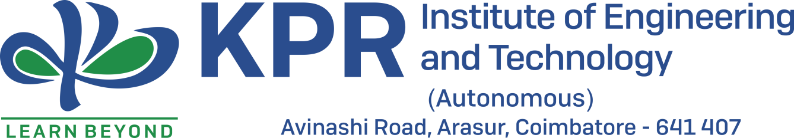

**IGNITRRON - 2021**



**“UNITED Thoughts UNITED OUTCOME”**

**IGNITRRON:**

Ignitrron KPRIET aims to technically enlighten the students skills in various sectors of upcoming technological world ,so as to cope up with the competitive environment .It is a place where students can enhance themselves into the technical world.

**VISION:**

The main goal of IGNITRRON is,

- improving the technological skills and knowledge,

- developing leadership qualities and team coordination among the Students of KPRIET.

**MISSION:**

To provide a forum for the student’s fraternity to grow and show their technical prowess in the areas of their Interest.

**SHORT TERM GOAL:**

To enable the smooth functioning of our 11 clubs and enhance technical knowledge, along with leadership and coordination skills, among the students.

**LONG TERM GOAL:**

To organize an elite national level tech fest, attracting tech enthusiasts from all corners of the country.